DATA STRUCTURES AND ALGORITHMS

WEEK ONE LABS

Immaculate Juma 134111

Melissa Mungai 134128

Millicent Cheptoi 133928

Ryan Koech 134138

Waguthi Warui 134093

1.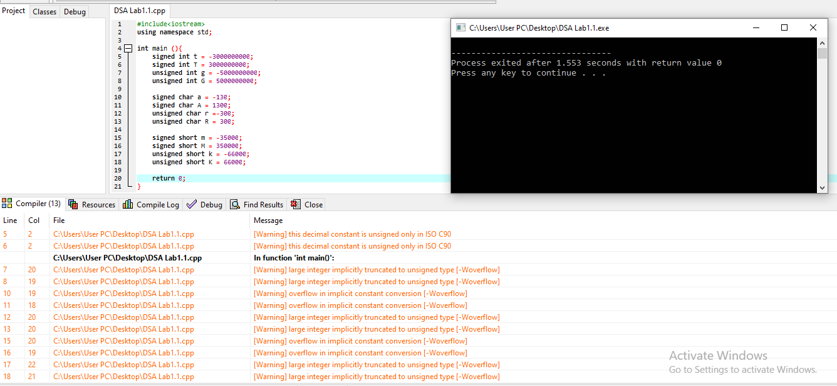

The signed char should store numbers between -128 and 127

The unsigned char should store positive numbers between 0 to 255

The signed short should store numbers between -32768 and 32767

The unsigned short should store numbers between 0 to 65535

2.

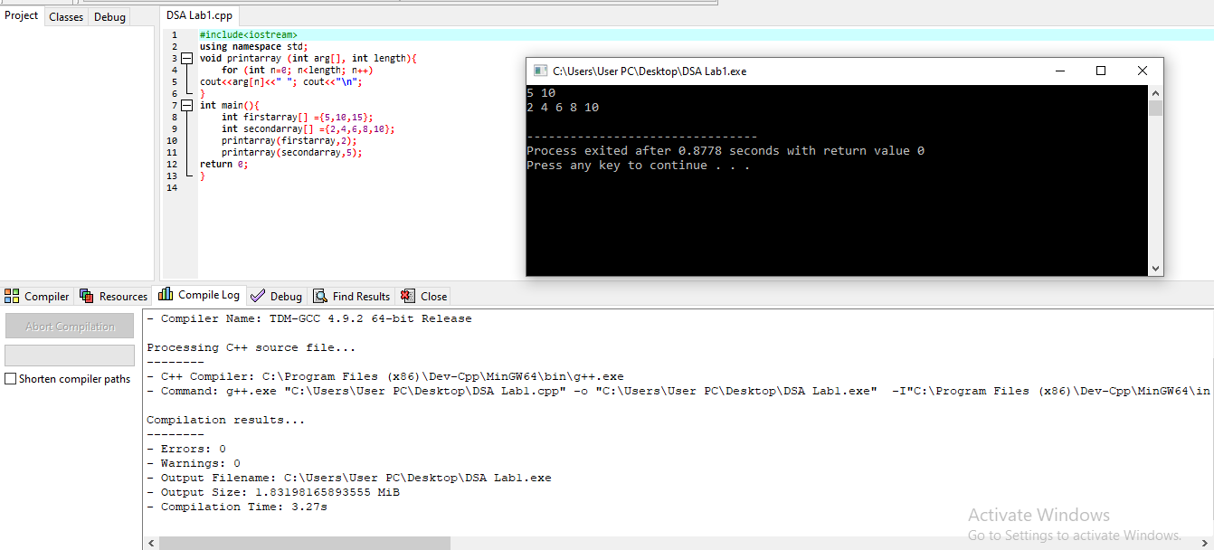

The compiler does not assume the default value to be zero but it starts from one when counting the digits stored in the array.